DEPARTMENT OF INFORMATION TECHNOLOGY
PUDUCHERRY TECHNOLOGICAL UNIVERSITY
VIII SEMESTER

IT233 – PROJECT WORK

ZEROTH REVIEW 1.1 PROJECT REPORT 2025-26

AGRITWIN-GH: AGRICULTURAL DIGITAL TWIN FOR SMART GREENHOUSE HORTICULTURE OF TOMATO AND STRAWBERRY CULTIVATION

UNDER THE SUPERVISION OF
DR. V. GOVINDASAMY
PROFESSOR
DEPARTMENT OF INFORMATION TECHNOLOGY
PUDUCHERRY TECHNOLOGICAL UNIVERSITY

SUBMITTED BY
ARJUN CHRISTOPHER - 2201112007
BHUVANALAKSHMI J P - 2201112009
VANTAPATI RAJA RAJESWARI - 2201112052

Approved Title – Signature of the Guide

REVIEW QUERIES

Question 1: Why does the Project title not clear and has no novel?
- Where is the novelty in your project title?
- Why is the plant type not clearly specified in the title?

Question 2: Why didn’t consider Real-Time Environmental and Native Data?
- Why have you not considered native or local environmental data?
- What environmental dataset are you using?

Question 3: Why didn’t consider Real-Time and Real Greenhouse Data?
- Why has a real-time dataset not been considered?
- Have you collected data from real greenhouses?

Question 4: Why didn’t consider Seasonal and Temporal Variations?
- How does your dataset account for season and time-based variations?

Question 5: What are Appropriate Parameters Selected?
- What parameters have you considered in your system?

Question 6: Why Formal Project Proposal not included?
- Where is the formal implementation plan?

Question 7: What is the Expected System Outcome?
- What is the final system outcome?

JUSTIFICATION 1: PROJECT TITLE CLARITY AND NOVELTY
QUESTION: Where is the novelty in your project title?
ANSWER:
- Clearly Defines the Core Innovation
The term “Digital Twin” highlights the main novelty — a software-based, data-driven virtual replica of a physical greenhouse system capable of prediction, simulation, and intelligent control.
- Specifies the Application Domain
“Smart Greenhouse Horticulture” emphasizes AI-assisted intelligent cultivation rather than conventional automation systems.
- Establishes Technical Identity
“AgriTwin-GH” uniquely brands the system as an Agricultural Digital Twin framework tailored specifically for greenhouse (GH) environments.

QUESTION: Why is the plant type not clearly specified in the title?
ANSWER:
- Removes Ambiguity by Specifying Crops
The inclusion of “Tomato and Strawberry Cultivation” clearly defines the plant types, strengthening scientific clarity and practical relevance.

JUSTIFICATION 2: ENVIRONMENTAL AND NATIVE DATA
QUESTION: Why have you not considered native or local environmental data?
ANSWER:
- Region-Specific Accuracy
Greenhouse behavior depends on local climatic conditions. Integrating native environmental data ensures realistic modeling aligned with regional weather patterns.
- Real-Time Adaptability
Incorporating direct real-time sensor streams would shift the project toward hardware-dependent implementation. Since the current phase focuses on a software-based digital twin framework, a Weather API is planned to be integrated instead of physical sensor deployment. This approach enables the system to utilize selected real-time environmental metrics (such as ambient temperature and relative humidity) while maintaining a purely software-oriented architecture.

QUESTION: What environmental dataset are you using?
ANSWER:
- Open-Source Environmental Datasets
The system utilizes publicly available open-source greenhouse and environmental datasets that provide structured parameters such as temperature, humidity, light intensity, soil metrics, and CO₂ levels.
- Hybrid Data Integration with Synthetic Parameters
Since a complete real-time greenhouse dataset covering all required parameters is not fully available, synthetic data is generated for selected parameters to simulate realistic greenhouse conditions.

JUSTIFICATION 3: REAL-TIME AND REAL GREENHOUSE DATA
QUESTION: Why has a real-time dataset not been considered?
ANSWER:
- Dynamic System Validation
Currently, there is no fully available real-time dataset covering all greenhouse parameters required for digital twin modeling. Therefore, the system uses available real-time environmental data (via Weather API) combined with synthetically generated parameters to simulate complete greenhouse conditions. This hybrid approach allows the virtual model to approximate real-world behavior while maintaining software feasibility.Enhanced Practical Relevance
Using real environmental streams (via Weather API and structured datasets) ensures that predictions are not purely theoretical.
- Data Reliability Through Structured Integration
The combination of open-source greenhouse datasets, available real-time environmental metrics, and controlled synthetic parameter generation ensures modeling continuity and robustness, even in the absence of a fully comprehensive real-time greenhouse dataset.

QUESTION: Have you collected data from real greenhouses?
ANSWER:
- Practical Constraints and Data Availability
Due to time constraints, real greenhouse data has not yet been collected directly from physical greenhouse facilities. However, the framework is structured to incorporate real greenhouse datasets in future phases if access becomes available.

JUSTIFICATION 4: SEASONAL AND TEMPORAL VARIATIONS
QUESTION: How does your dataset account for season and time-based variations?
ANSWER:
- Incorporation of Time-Stamped Environmental Data
The system uses time-stamped environmental inputs (temperature, humidity, light patterns) so that variations across months and seasons can be captured and analyzed instead of treating data as static values.
- Season-Aware Modeling Logic
Seasonal patterns are embedded into the digital twin through time-series analysis, allowing the system to recognize recurring climatic trends that influence crop growth and disease probability.
- Growth Stage Mapping with Calendar Cycles
Tomato and strawberry cultivation cycles are mapped against seasonal timelines, enabling the model to align vegetative, flowering, fruiting, and harvest stages with expected seasonal conditions.

JUSTIFICATION 5: PARAMETER SELECTION
QUESTION: What parameters have you considered in your system?
ANSWER:
- Environmental Parameters
Air temperature, relative humidity, light intensity, photoperiod, CO₂ concentration, ventilation rate, air circulation, and leaf wetness.
- Growth and Crop Factors
Soil pH, electrical conductivity (EC), and crop growth stages (vegetative, flowering, fruiting, harvest).
- Disease and Stress Indicators
High humidity duration, nutrient imbalance (e.g., calcium deficiency), and abnormal sensor readings.
- Structured Categorization
Parameters are grouped logically into Environmental, Crop, and Disease categories to support predictive analytics and control optimization.

JUSTIFICATION 6: FORMAL PROJECT PROPOSAL
QUESTION: Where is the formal implementation plan?
ANSWER:
- Structured Proposal Included
The revised report now includes objectives, system architecture, data sources, modeling strategy, and evaluation framework.
- Clear Methodology Definition
The proposal explains data ingestion, AI modeling (CNN + RNN + classical ML), digital twin simulation, and predictive control mechanisms.
- Feasibility Through Modular Design
The system is structured into data processing, AI inference, and digital twin control modules, enabling scalable implementation.
- Defined Expected Outcomes
Each module has measurable outputs such as disease risk index, growth stage classification, and resource optimization metrics.

JUSTIFICATION 7: SYSTEM OUTCOME
QUESTION: What is the final system outcome?
ANSWER:
- Crop Health & Disease Risk Indicator
The system generates a structured crop health assessment along with a quantified disease risk indicator based on environmental parameters, image analysis, and predictive modeling. This enables early identification of potential stress or infection conditions.
- Growth Stage & Harvest Readiness Signal
The system provides classification of crop growth stages (vegetative, flowering, fruiting, harvest) and generates a harvest readiness signal. This supports informed decision-making regarding irrigation, nutrient management, and harvesting timing.

TABLE OF CONTENTS

Title | Page No.
1. Abstract …………………………………………………………….. | 1
2. Introduction ………………………………………………………... | 1
3. Project Objectives ………………………………………………….. | 3
4. Literature Survey …………………………………………………... | 3
5. Inference from Literature Survey …………………………………... | 4
6. Need for the Proposed Work ……………………………………….. | 4
7. Proposed Work ……………………………………………………... | 5
7.1 High-Level Architecture ……………………………………….. | 5
7.2 System Inputs and Expected Output ……………………………. | 6
7.3 Project Modules …………………...…………………………… | 7
7.4 Implementation Details ………………………………………… | 8
7.5 Hardware Requirements ………………………………………... | 9
7.6 Software Requirements ………………………………………… | 9
7.7 Project Development Timeline ………………………………………. | 10
8. Conclusion …………………………………………………………. | 11
9. Datasets Used ………………………………………………………. | 11
10. References ………………………………………………………... | 11

LIST OF FIGURES

Figure No. | Figure Title | Page No.
2.1 | Conceptual Digital Twin Architecture for Greenhouse Cultivation ….… | 2
7.1 | High-Level Architecture Diagram for Proposed AgriTwin-GH Framework ……………..……………………………………………… | 6
7.2 | Module-Level Workflow of Unified Data Processing ……………......... | 7
7.3 | Module-Level Workflow of Predictive Analytics & Classification ……. | 8
7.4 | Module-Level Workflow of Digital Twin and Model Predictive Control | 8
7.5 | Phase-wise Project Gantt Chart ………………………………………... | 10

ABBREVIATIONS

Abbreviation |  | Full Form
AI | Artificial Intelligence
CNN | Convolutional Neural Network
RNN | Recurrent Neural Network
LSTM | Long Short-Term Memory
DT | Digital Twin
MPC | Model Predictive Control
VPD | Vapor Pressure Deficit
CO₂ | Carbon Dioxide
EC | Electrical Conductivity
IoT | Internet of Things
CV | Computer Vision
ML | Machine Learning
DL | Deep Learning
GUI | Graphical User Interface
API | Application Programming Interface
RGB | Red, Green, Blue
CPU | Central Processing Unit
GPU | Graphics Processing Unit
API | Application Programming Interface

1. ABSTRACT
Greenhouse cultivation of high-value crops such as tomatoes and strawberries faces persistent challenges related to environmental variability, delayed disease detection, inefficient resource usage, and reliance on reactive manual decision-making. Conventional greenhouse management systems often lack predictive intelligence and fail to provide early warnings for disease risks, resulting in yield loss, quality degradation, and excessive consumption of water, energy, and fertilizers.
To address these limitations, this project presents AgriTwin-GH, a software-based AI-powered digital twin framework for smart greenhouse management. The proposed framework leverages data-driven analysis of greenhouse environmental conditions and plant health information to enable early disease risk awareness, future condition assessment, and proactive decision support. Instead of relying on physical sensor infrastructure, the system operates using open-source greenhouse datasets and plant image data, allowing flexible experimentation and cost-effective deployment.
AgriTwin-GH provides disease-aware predictions, greenhouse condition forecasts, and safety-validated control recommendations, which are translated into simple non-verbal operational alerts for practical usability in labor-intensive greenhouse environments. By shifting greenhouse operations from reactive responses to predictive and preventive management, the framework improves crop productivity and quality while significantly reducing unnecessary water, energy, and fertilizer usage.
The results offer a scalable, resource-efficient, and decision-oriented digital twin solution for precision greenhouse horticulture, making it particularly suitable for resource-constrained and small-to-medium-scale farming systems.
Keywords
Digital Twin, Smart Greenhouse, Time-Series Dataset, Plant Image Dataset, CNN, RNN, Model Predictive Control, Disease Prediction, Precision Agriculture

2. INTRODUCTION

Digital Twin technology enables the creation of virtual representations of physical systems that mirror real-world behavior in real time. By integrating data acquisition, system modeling, and intelligent analytics, a digital twin can analyze current conditions, predict future states, and support informed decision-making. This capability allows what-if analysis, reducing operational risk by validating decisions virtually before applying them to physical systems.

The application of digital twins has expanded from industrial domains to areas such as energy systems and agriculture. In controlled-environment agriculture, particularly greenhouse cultivation, digital twins are highly relevant due to the strong dependence of crop growth on environmental parameters such as temperature, humidity, light intensity, carbon dioxide concentration, irrigation, and nutrient levels. Greenhouses enable year-round cultivation of high-value crops such as tomato and strawberry, but even minor deviations from optimal conditions can result in yield loss, quality reduction, or increased disease susceptibility.

The conceptual working of a digital twin–based greenhouse system is illustrated in Fig. 2.1. The framework shows a continuous interaction between the physical greenhouse and its virtual counterpart. Environmental data collected from the greenhouse are transmitted to the digital twin, where system models and artificial intelligence algorithms analyze current conditions, predict future states, and evaluate control strategies. Based on this analysis, optimized decisions are fed back to the physical greenhouse, forming a closed-loop control system.
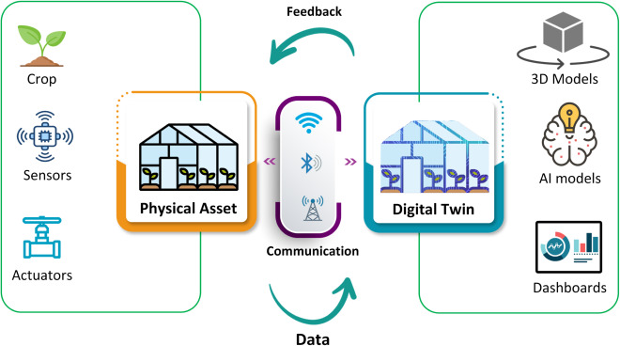
Fig. 2. 1 Conceptual Digital Twin Architecture for Greenhouse Cultivation
Traditional greenhouse management practices are largely reactive and depend on manual observation, fixed threshold-based control, and operator experience. Corrective actions are often taken only after visible symptoms of plant stress or disease appear, leading to inefficient use of water, energy, fertilizers, and chemical treatments. Although greenhouse data are continuously collected, they are often underutilized for predictive analysis, limiting long-term system improvement.
Greenhouse systems are inherently complex, consisting of interacting subsystems such as climate control, ventilation, irrigation, lighting, and nutrient management. Control actions in one subsystem may unintentionally affect others, making static or rule-based strategies insufficient. In addition, uncertainties arising from weather variations, sensor noise, and biological variability among plants further complicate greenhouse management.
Recent advances in data-driven modeling enable early identification of unfavorable environmental trends and disease risks. Digital twin–based management strengthens this capability by allowing virtual experimentation and safe evaluation of control actions before real-world implementation. Motivated by these advantages, this work proposes AgriTwin-GH, a software-based digital twin framework for intelligent greenhouse management focused on tomato and strawberry cultivation. The proposed system aims to support early risk detection, efficient resource utilization, and improved decision-making in greenhouse environments.

3. PROJECT OBJECTIVES
The primary objective of this project is to design a software-based digital twin framework for intelligent greenhouse management using agricultural data. The system aims to predict greenhouse environmental conditions and support adaptive control through data-driven models. Another objective is to enable early detection and forecasting of plant disease risks using artificial intelligence techniques, allowing preventive action before visible symptoms appear. The project also focuses on reducing dependence on manual and reactive decision-making by supporting proactive and preventive greenhouse management. In addition, the system aims to improve efficient use of water and energy resources and to provide simple, non-verbal operational alerts that are easy for greenhouse workers to understand. Finally, the proposed framework is intended to be scalable and cost-effective so that it can be applied to different greenhouse configurations without requiring complex infrastructure.

4. LITERATURE SURVEY
Subahi and Bouazza proposed an IoT-based greenhouse temperature monitoring and control system focused on reducing energy consumption while maintaining suitable growing conditions [10]. Their system integrates sensor data with intelligent control mechanisms to regulate greenhouse temperature efficiently. The study shows that automated control performs better than traditional on–off control methods, highlighting the importance of intelligent environmental regulation in greenhouses.
Tathed presented an AI-driven agricultural platform that integrates data from multiple sources such as sensors and imagery to support decision-making across the crop lifecycle [11]. The system applies machine learning techniques for yield prediction, disease detection, and irrigation planning. The results demonstrate improved water-use efficiency and crop yield, emphasizing the role of AI-based prediction in sustainable agriculture management.
Howard et al. introduced a digital twin–based Industry 4.0 framework for commercial greenhouses that integrates IoT, artificial intelligence, and data analytics. Their work mainly focuses on optimizing energy usage, production efficiency, and operational costs [2]. The study demonstrates how digital twins can support decision-making by simulating greenhouse operations and evaluating different control strategies.
Ghiasi et al. proposed an energy-efficient greenhouse climate control approach using optimization techniques [1]. Their framework maintains temperature, humidity, and carbon dioxide levels within suitable ranges while minimizing energy cost. The study highlights that predictive and optimization-based control strategies outperform conventional rule-based greenhouse control methods.
Umar et al. focused on plant disease detection using deep learning techniques for tomato crops. Their work applies convolutional neural networks to identify multiple leaf diseases with high accuracy under real-world conditions [12]. The study shows that image-based disease detection can significantly improve early diagnosis and crop health monitoring.

5. INFERENCE FROM LITERATURE SURVEY
From the literature survey, it is observed that most existing digital twin–based greenhouse systems mainly focus on energy efficiency, climate regulation, and production optimization. While these approaches are effective for reducing operational costs, they provide limited support for plant health monitoring and disease-aware decision-making. Resource optimization is largely centered on energy usage, with less attention given to preventive management of water, fertilizer, and crop health through early intervention.
It is also noted that many existing greenhouse control systems follow a reactive approach, where actions are taken only after environmental thresholds are exceeded or visible crop stress appears. Such methods do not support early prediction of plant stress or disease risk. Moreover, the interaction between environmental conditions, crop behavior, and disease development is not adequately modeled, resulting in an incomplete representation of real greenhouse dynamics.
In addition, most existing solutions lack plant-centric intelligence such as image-based disease detection and disease progression forecasting. Disease assessment is often indirect and system outputs are not designed for easy interpretation by greenhouse workers. These limitations highlight the need for an integrated, predictive, and plant-aware digital twin framework with simple and intuitive decision support.

6. NEED FOR PROPOSED WORK
The limitations identified in existing digital twin–based greenhouse systems indicate the need for a plant-centric digital twin framework that goes beyond energy and production optimization to include crop health intelligence. Greenhouse environments are highly sensitive systems where plant growth, disease development, and resource usage are closely interrelated. Systems that do not explicitly consider plant health and disease behavior fail to provide complete agronomic decision support. Hence, there is a need for an integrated approach that combines crop, environment, and disease information to enable preventive and efficient greenhouse management.
Most existing greenhouse control systems rely on reactive mechanisms, where actions are taken only after unfavorable conditions or visible disease symptoms appear. Such approaches are insufficient for early disease prevention. This creates the need for predictive and anticipatory management using data-driven models that can forecast environmental changes and disease risk in advance, allowing timely intervention and reduced crop loss.
Additionally, current systems lack direct plant observation and user-friendly decision delivery. Integrating image-based disease detection using deep learning can improve the accuracy of crop health assessment. Providing simple and intuitive alerts further ensures practical usability for greenhouse workers. Addressing these needs is essential to develop an intelligent, predictive, and user-centric digital twin framework for greenhouse management.

7. PROPOSED WORK
This work proposes AgriTwin-GH, an AI-powered digital twin framework for smart greenhouse management with a focus on plant health monitoring and early disease prediction for tomato and strawberry crops. Unlike existing systems that mainly emphasize energy and production efficiency, the proposed framework integrates crop, environment, and disease information into the decision-making process to support proactive greenhouse management.
The system uses open-source greenhouse datasets as virtual sensors to collect environmental parameters such as temperature, humidity, CO₂ concentration, light intensity, soil moisture, electrical conductivity, and pH. In addition, plant image datasets representing different growth stages and disease conditions are used to directly assess crop health. The data are preprocessed and analyzed to generate meaningful indicators that represent real greenhouse behavior without relying on physical sensor infrastructure.
To improve crop health assessment, the proposed system applies deep learning techniques for image-based plant disease detection. Environmental data and historical patterns are analyzed to predict disease risk trends over time. A digital twin simulation layer continuously reflects the greenhouse state and evaluates alternative control actions such as irrigation, ventilation, and humidity control through virtual experimentation.
The system follows a predictive approach rather than reactive threshold-based control, enabling early intervention before severe crop stress or disease outbreaks occur. Decision outputs are presented using simple, intuitive alerts to ensure easy understanding by greenhouse workers. Overall, the proposed AgriTwin-GH framework aims to improve crop health, support timely decision-making, and enable efficient greenhouse management in a practical and scalable manner.
7.1 HIGH-LEVEL ARCHITECTURE
Fig. 7.1 illustrates the high-level architecture of the proposed AgriTwin-GH framework, depicting the flow of data from input acquisition to intelligent decision outputs. The architecture is structured into three primary layers: input data sources, core processing modules, and system outputs.
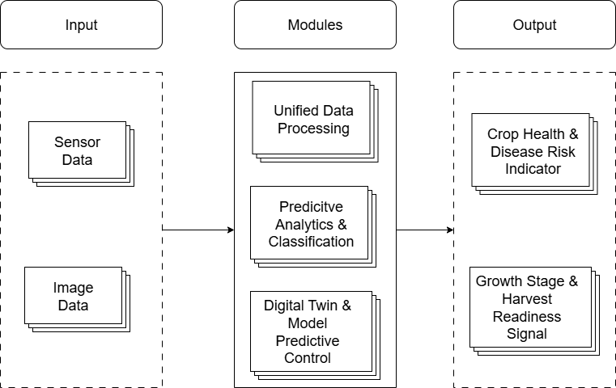
Fig. 7. 1 High-Level Architecture Diagram for Proposed Work
7.2 SYSTEM INPUTS AND EXPECTED OUTPUT
A. System Inputs
The proposed system operates using data-driven inputs obtained from open-source datasets and selected real-time API-based environmental data that emulate real greenhouse environments. These datasets act as virtual sensors, enabling experimentation and analysis without relying on physical sensor infrastructure, while still reflecting realistic greenhouse behavior.
1. Open-Source Environmental Data
The system uses open-source greenhouse datasets that provide time-series environmental parameters. These datasets function as virtual sensor streams and include variables such as temperature, humidity, light intensity, carbon dioxide (CO₂) concentration, soil moisture, electrical conductivity, and soil pH. The data support greenhouse condition analysis, prediction, and digital twin simulation. In addition, a Weather API is integrated to retrieve selected real-time environmental metrics such as ambient temperature and relative humidity. While not a full greenhouse sensor deployment, the API-based data introduce real-time adaptability into the software framework. The combined environmental inputs support greenhouse condition analysis, prediction, and digital twin simulation.
2. Open-Source Plant Image Data
Plant image datasets related to tomato and strawberry cultivation are used to assess crop health and growth stages. These images include healthy and diseased leaves and different growth phases. Image data enable visual identification of disease symptoms and crop development, strengthening plant health analysis.
B. System Outputs and Expected Outcomes
The system produces outputs that support predictive decision-making and intelligent greenhouse management.
1. Crop Health and Disease Risk Indicator
This output provides an overall assessment of plant health and disease risk by combining environmental data and image-based analysis. It supports early detection of potential disease conditions and preventive greenhouse management.
2. Growth Stage and Harvest Readiness Signal
The system identifies the current growth stage of crops and indicates harvest readiness, especially for strawberry cultivation, where correct harvest timing is critical for quality and yield.
3. Expected Outcomes
The expected outcomes include successful demonstration of a sensor-independent digital twin framework, early disease risk identification, accurate growth stage prediction, improved decision support, and reduced dependence on physical greenhouse infrastructure.
7. 3. PROJECT MODULES
The proposed AgriTwin-GH framework is organized into three tightly coupled functional modules that collectively enable data-driven intelligence, predictive analytics, and digital twin–based control optimization. Each module performs a distinct role while maintaining seamless interoperability across the system.
A. Unified Data Processing
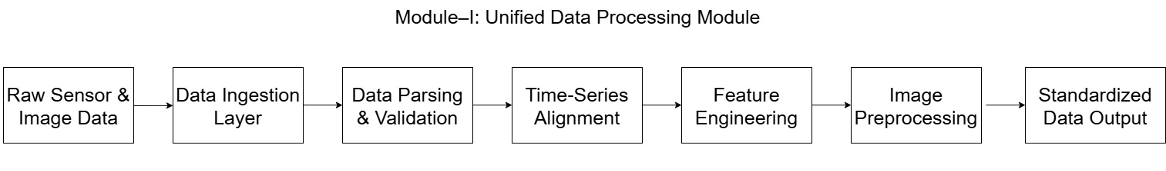Fig. 7. 2 Module-Level Workflow of Unified Data Processing
Fig. 7.2 illustrates the Unified Data Processing module, which serves as the data preparation and transformation layer of the system. It converts raw open-source sensor streams, Weather API inputs, and image datasets into structured and standardized inputs suitable for AI modeling and digital twin simulation. The primary responsibilities of this module include parsing and validating heterogeneous sensor datasets, handling missing values and noisy measurements, and performing time-series alignment across multiple data sources. Feature extraction and normalization are applied to ensure consistency and comparability across input variables. For image data, preprocessing operations such as resizing, normalization, and feature extraction are performed to generate model-ready representations. By standardizing heterogeneous data sources, including selected real-time environmental metrics retrieved through the Weather API, this module establishes a reliable foundation for downstream analytics and simulation.
B. Predictive Analytics and Classification
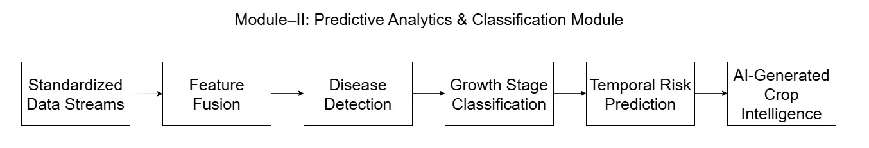Fig. 7. 3 Module-Level Workflow of Predictive Analytics & Classification
Fig. 7. 3 focuses the Predictive Analytics and Classification module constitutes the decision-making core of the proposed system. It applies machine learning and deep learning models to infer crop health status, growth stages, and disease risk using processed sensor-derived features and visual information. The major functions of this module include crop health classification through integrated sensor and image analysis, early disease detection and risk estimation, growth stage identification based on temporal and visual cues, and harvest readiness prediction for fruit-bearing crops. The predictive outputs generated by this module are continuously updated and forwarded to the digital twin layer for validation and control optimization.
C. Digital Twin and Model Predictive Control
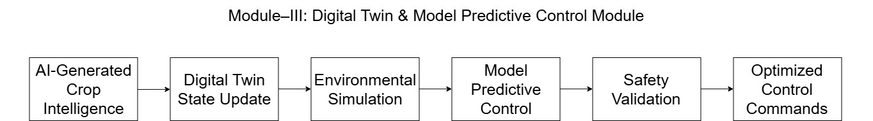Fig. 7. 4 Module-Level Workflow of Digital Twin & Model Predictive Control
Fig. 7. 4 focuses the Digital Twin and Model Predictive Control (MPC) module represents a virtual replica of the greenhouse system, constructed using open-source data and learned system dynamics. This module maintains a real-time virtual state of the greenhouse, simulates environmental evolution under alternative control strategies, and forecasts system behavior over short-term horizons. Using Model Predictive Control, the digital twin evaluates and optimizes control actions such as ventilation adjustment, irrigation scheduling, lighting regulation, humidity control, and temperature management. By validating AI-generated recommendations through simulation prior to deployment, this module ensures that control decisions are both effective and agronomically safe.
7. 4 IMPLEMENTATION DETAILS
The system is implemented entirely in a Python-based software environment, where open-source time-series datasets are utilized as virtual sensors to represent greenhouse environmental and crop conditions. These datasets simulate real-time sensor behavior and are processed continuously to support analytics and predictive modeling. In parallel, plant image datasets related to tomato and strawberry cultivation are employed to simulate real-time crop observation, enabling disease detection, growth stage identification, and harvest readiness assessment through computer vision techniques.
The core digital twin engine integrates data processing, predictive analytics, and control simulation. It performs short-term forecasting, disease risk analysis, and evaluation of alternative control strategies such as irrigation scheduling, ventilation adjustment, humidity control, and temperature regulation. All AI models, including machine learning and deep learning components, are executed within the Python environment, ensuring modularity, reproducibility, and platform independence.
7. 5 HARDWARE REQUIREMENTS
- Standard personal computer or laptop
- Processor: Intel i5 or AMD Ryzen 5 (or equivalent)
- Main memory: Minimum 8 GB RAM
- Storage: 20–30 GB available disk space
- Graphics processing unit (GPU): Optional (recommended for accelerating deep learning tasks)
7. 6 SOFTWARE REQUIREMENTS
- Operating System: Windows / Linux / macOS
- Programming Language: Python 3.x
- AI & Data Libraries:
- TensorFlow / Keras
- NumPy, Pandas
- Scikit-learn
• API Integration:
o Weather API
o FastAPI
- Visualization: Flask / Streamlit
- Development Tools: Jupyter Notebook / VS Code

7. 7 PROJECT DEVELOPMENT TIMELINE
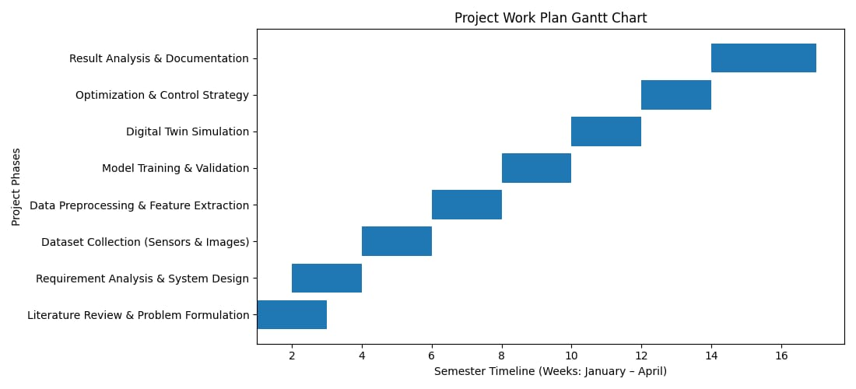
Fig. 7. 5 Phase-wise Project Gantt Chart
Fig. 7. 5 illustrates the overall project development timeline, showing a sequential, phase-wise progression from literature review to result analysis and documentation. Each phase is allocated a specific time window across the January–April semester period, ensuring systematic execution and timely completion of the project.
Phase-wise Project Timeline
Project Phase | Duration (Weeks) | Time Period (Month)
Literature Review & Problem Formulation | Weeks 1–2 | January
Requirement Analysis & System Design | Weeks 2–3 | January
Dataset Collection (Sensors & Images) | Weeks 4–5 | February
Data Preprocessing & Feature Extraction | Weeks 6–7 | February
Model Training & Validation | Weeks 8–9 | Late February – Early March
Digital Twin Simulation | Weeks 10–11 | March
Optimization & Control Strategy | Weeks 12–13 | Late March
Result Analysis & Documentation | Weeks 14–16 | April

8. CONCLUSION
AgriTwin-GH demonstrates the potential of a software-based, AI-driven digital twin framework for intelligent greenhouse management of tomato and strawberry crops. By integrating environmental data analysis, plant disease detection, and virtual greenhouse modeling, the proposed system supports predictive and proactive decision-making. Unlike traditional reactive greenhouse systems, AgriTwin-GH enables early risk identification and virtual validation of control actions, leading to improved crop health and more efficient resource usage. The results indicate that a sensor-independent digital twin can effectively represent greenhouse behavior and serve as a practical decision-support tool for smart agriculture.
Future Enhancements
Future work aims to enhance the scalability and real-world applicability of the proposed system. Planned improvements include integrating real-time IoT sensors for live synchronization between the physical greenhouse and the digital twin, extending the framework to additional crops and disease models, and incorporating advanced learning techniques for adaptive control. Further, deploying edge-based AI solutions can enable faster, on-site decision-making in resource-constrained environments. These enhancements will strengthen AgriTwin-GH as a flexible and scalable platform for precision greenhouse management.

9. DATASETS USED
1. Greenhouse Plant Growth Metrics Dataset.
Available: https://www.kaggle.com/datasets/adilshamim8/greenhouse-plant-growth-metrics
2. Ripe Strawberries Detection Dataset.
Available: https://www.kaggle.com/datasets/trainingdatapro/ripe-strawberries-detection
3. Smart Agriculture Dataset.
Available: https://www.kaggle.com/datasets/chaitanyagopidesi/smart-agriculture-dataset/data
4. Tomato Plant Stages Dataset.
Available: https://www.kaggle.com/datasets/arjunsudheer326/tomato-plant-stages-dataset

10. REFERENCES
[1] M. Ghiasi, Z. Wang, M. Mehrandezh, and A. Mohammadi, “Optimal strategy for energy-efficient management of greenhouse climate control,” IEEE Open Access Journal of Power and Energy, vol. 12, pp. 1–14, December 5, 2025.
[2] D. A. Howard, Z. Ma, C. Veje, A. Clausen, J. M. Aaslyng, and B. N. Jørgensen, “Greenhouse industry 4.0 – digital twin technology for commercial greenhouses,” Energy Informatics, vol. 4, no. 1, pp. 1–20, May 2021.
[3] D. S. Joseph, P. M. Pawar, and K. Chakradeo, “Real-time plant disease dataset development and detection of plant disease using deep learning,” IEEE Access, vol. 11, pp. 1–15, 2023.
[4] A. Kaur and R. Kaur, “AI-enabled energy management for sustainable smart greenhouses: An integrated review,” Journal of Cleaner Production, vol. 382, pp. 1–15, 2024.
[5] D. K. Lee, B. K. Kang, Y. J. Kim, T. G. An, and Y. T. Chae, “A digital twin-based framework for precision tomato cultivation: Integrating XGBoost-based prediction with model predictive control,” SSRN Electronic Journal, 2024.
[6] S. R. Luna, M. P. García, and J. R. Torres, “Digital twin technology in greenhouse-based precision agriculture,” Computers and Electronics in Agriculture, vol. 209, pp. 107–119, 2023.
[7] B. V. Nikitha, N. K. S. Keerthan, P. Praneeth, and T. Amrita, “Leaf disease detection and classification,” Procedia Computer Science, vol. 218, pp. 291–300, January 2023.
[8] A. Oad, S. S. Abbas, A. Zafar, and others, “Plant leaf disease detection using ensemble learning and explainable AI,” IEEE Access, vol. 12, pp. 156038–156052, 2024.
[9] A. Soussi, E. Zero, C. D. C. Herrera, and others, “Integrating digital twins and model predictive control for sustainable greenhouse management in smart agriculture,” IEEE Transactions on AgriFood Electronics, vol. 1, no. 1, pp. 1–17, 2025.
[10] A. F. Subahi and K. E. Bouazza, “An intelligent IoT-based system design for controlling and monitoring greenhouse temperature,” IEEE Access, vol. 10, pp. 1–12, 2022.
[11] R. A. Tathed, “Designing AI-driven platforms to transform agricultural ecosystems,” International Journal for Research Publication and Seminar, vol. 16, no. 2, pp. 249–268, April–June 2025.
[12] M. Umar, S. Altaf, S. Ahmad, H. Mahmoud, A. S. N. Mohamed, and R. Ayub, “Precision agriculture through deep learning: Tomato plant multiple diseases recognition with CNN and improved YOLOv7,” IEEE Access, vol. 12, pp. 49167–49180, April 1, 2024.

